CHOX Concurrent Bordereau Upload Load Test Results Analysis

Introduction
There has been an issue in CHOX when multiple bordereaus are simultaneously uploaded and processed. When this occurs, CHOX eventually runs out of resources (database connections, tomcat threads). It can recover but sometimes the problem becomes so severe that the server needs to be restarted.

The cause of this behavior was identified as the bordereau monitoring process, which fires a request of to monitor the processing of the bordereau every 1.5s. The processing of these requests requires synchronized access to the session (implying that they must be processed sequentially rather than in parallel), and when the server is under load these requests start to queue/block, which generates more contention on the synchronized block which further aggravates the problem. The fix was to not fire the monitoring request every 1.5s, but to only fire a request 1.5s after the response from the previous request was received.

To verify this fix, these jmeter load tests have been written to duplicate this scenario and verify the application behavior both with and without this fix.

This is also the cause of the problems experienced in CHOX when we switched to Java 8. However, why this occurs so much more frequently under java 8 is still not clear, although it is suspected that a general increased request latency under java 8 is the cause. These tests, as well as the general load tests, will be also be ran under Java 8 so that we can determine any changes to the application behavior caused by this switch.

Test Plan Overview
As the bordereau monitoring requests are fired by javascript timers and not directly by the user, it is not possible to have a single jmeter test script that replicates the two distinct use cases (before and after the fix). Therefore two separate test scripts were written, both replicating the same functionality (users, data, etc) but one scripts replicates the old behavior of sending a request every 1.5s, while the other sends a request only after receiving a response from the previous request.

Both scripts consist of 2 common ‘thread groups’. The first is the set-up (or initializing) thread group. This authenticates the user and uploads a bordereau. This thread group must complete before the following thread groups are started. The second is the thread group that makes the call to process the bordereau. This also signals the remaining thread group (or groups) when the processing has finished so that the monitoring process can also finish.

The pre-fix test then has another thread group per bordereau upload. Each thread group has 40 users and a constant throughput of 40 requests per minute, approximating a request every 1.5s per bordereau being processed.

The post-fix test has one monitoring thread group, which sends consecutive monitoring request for each bordereau being processed (i.e. sends a request only after previous request’ response has been received).

The tests allow for up to 10 concurrent bordereau uploads. However these tests were ran using 4 concurrent bordereau uploads, with the bordereaus containing 296, 401, 102 & 431
claims each respectively. This number was tuned to the point where request failures were starting to be experienced in the pre-fix version of CHOX.
The tests were ran on three different CHOX installations (the Systems-under-test or SUT), which are:
- CHOX v8.5.3, the pre-fix version (and previous production system)
- CHOX v8.6.4, the post-fix and current production system
- CHOX v8.7.rc1, Phase 9 Sprint 8 release candidate (also post-fix)

It should also be noted that these test only replicate the bordereau processing and monitoring process. There is no other activity on the system when these tests are being performed. This is very different than in the operational context when there are generally 400+ other users performing their daily activities.

Results
On the pre-fix version (CHOX v8.5.3), the test took 8 minutes, and of the 4 bordereaus uploaded, only 3 were successfully processed. There were also 33 failed monitoring requests and 10 ‘out of database connection’ errors.

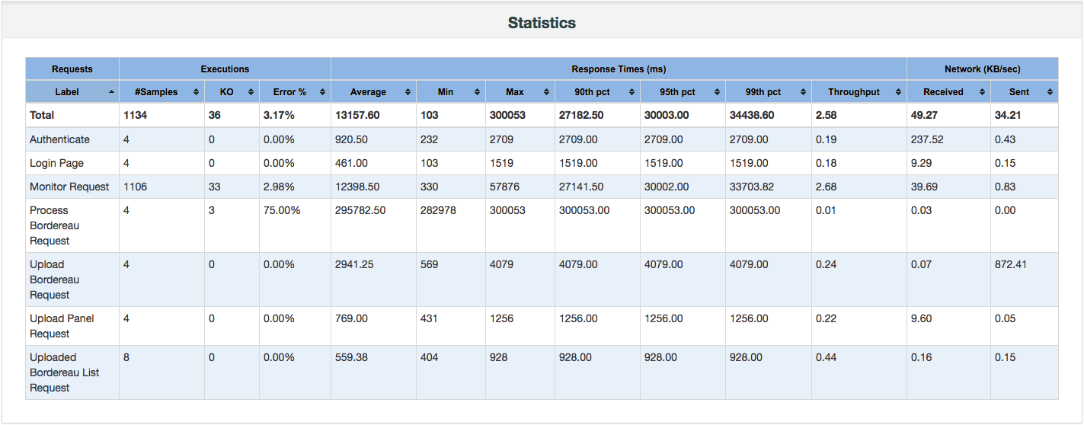

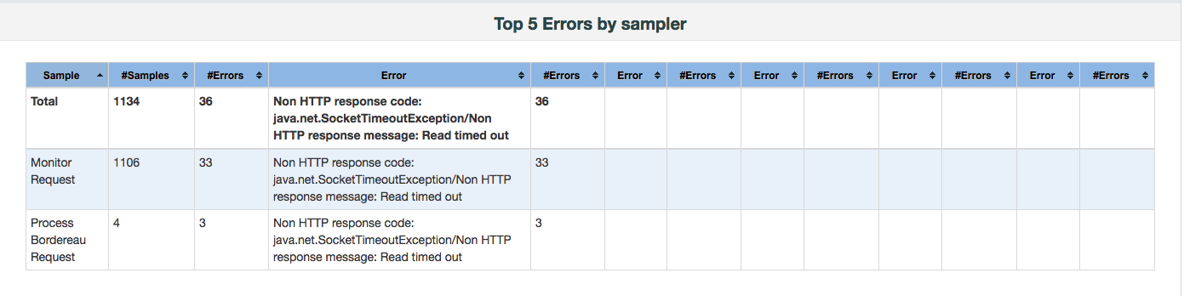
This compares to a running time of 4mins with no errors for both of the other SUTs.
CHOX v8.6.4:
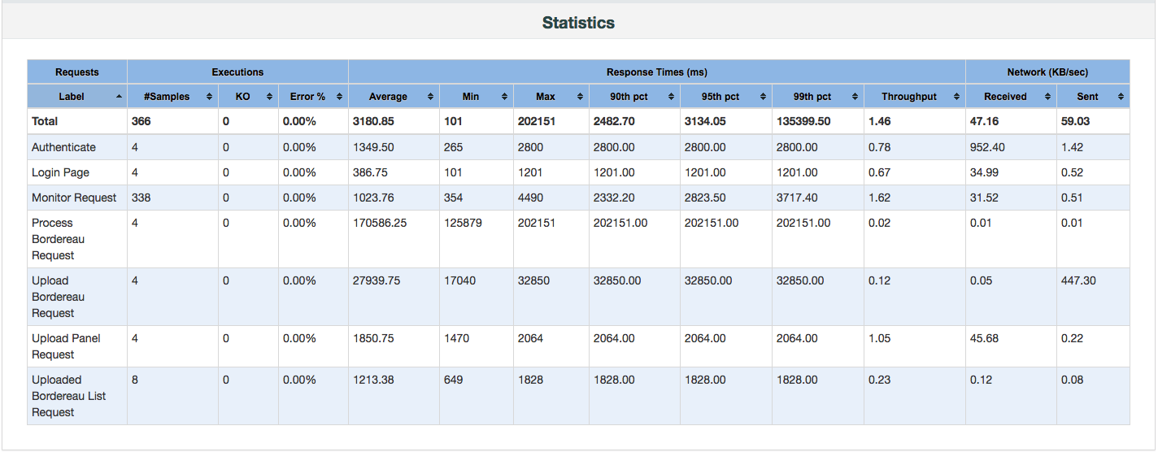

CHOX v8.7.rc1:
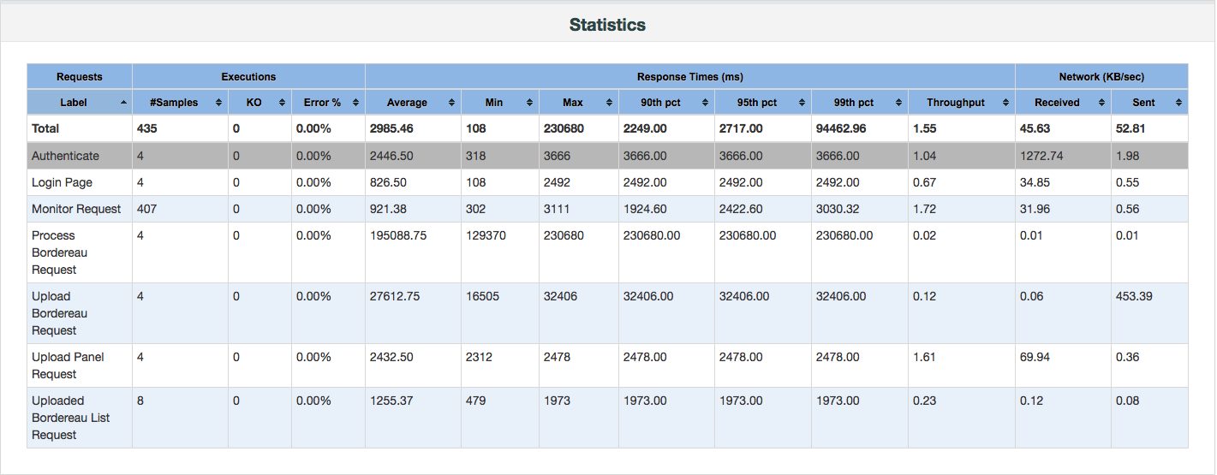

You can see a gradual increase in the response latencies of the bordereau monitoring requests over the first few minutes:
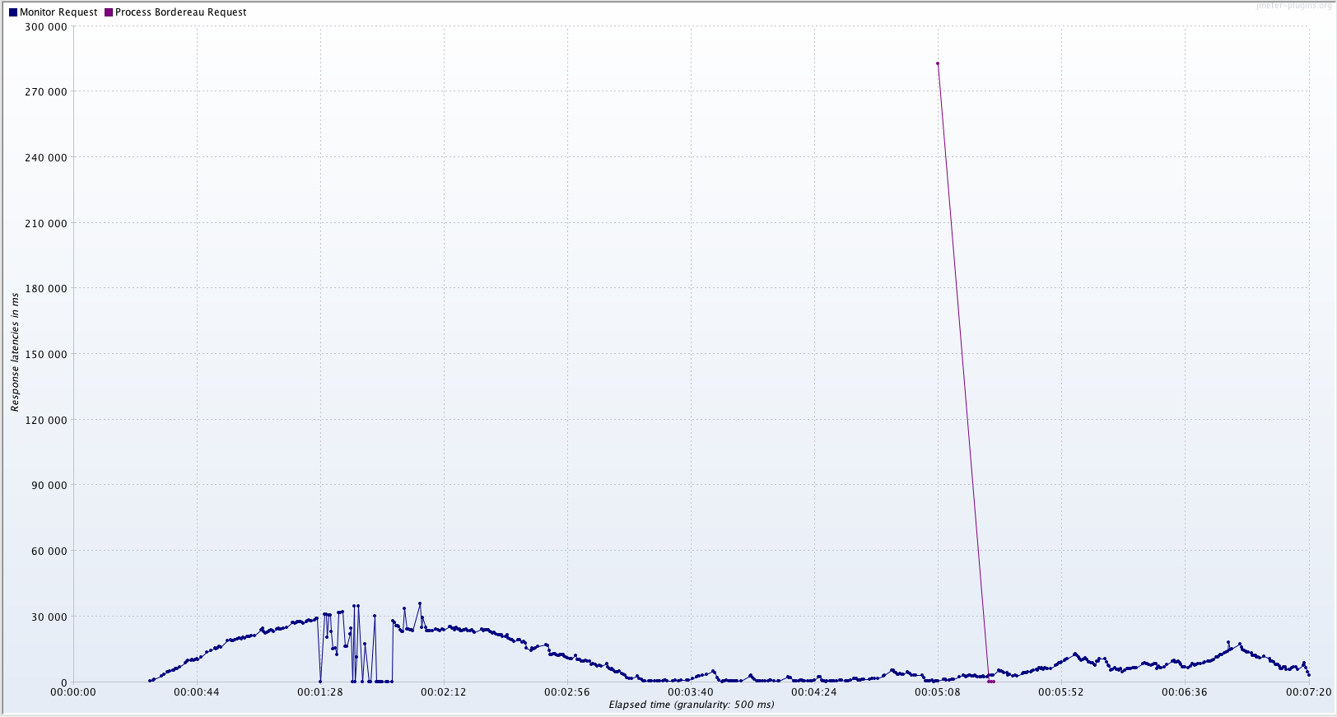

with response errors starting to occur around the 1:28 mark:
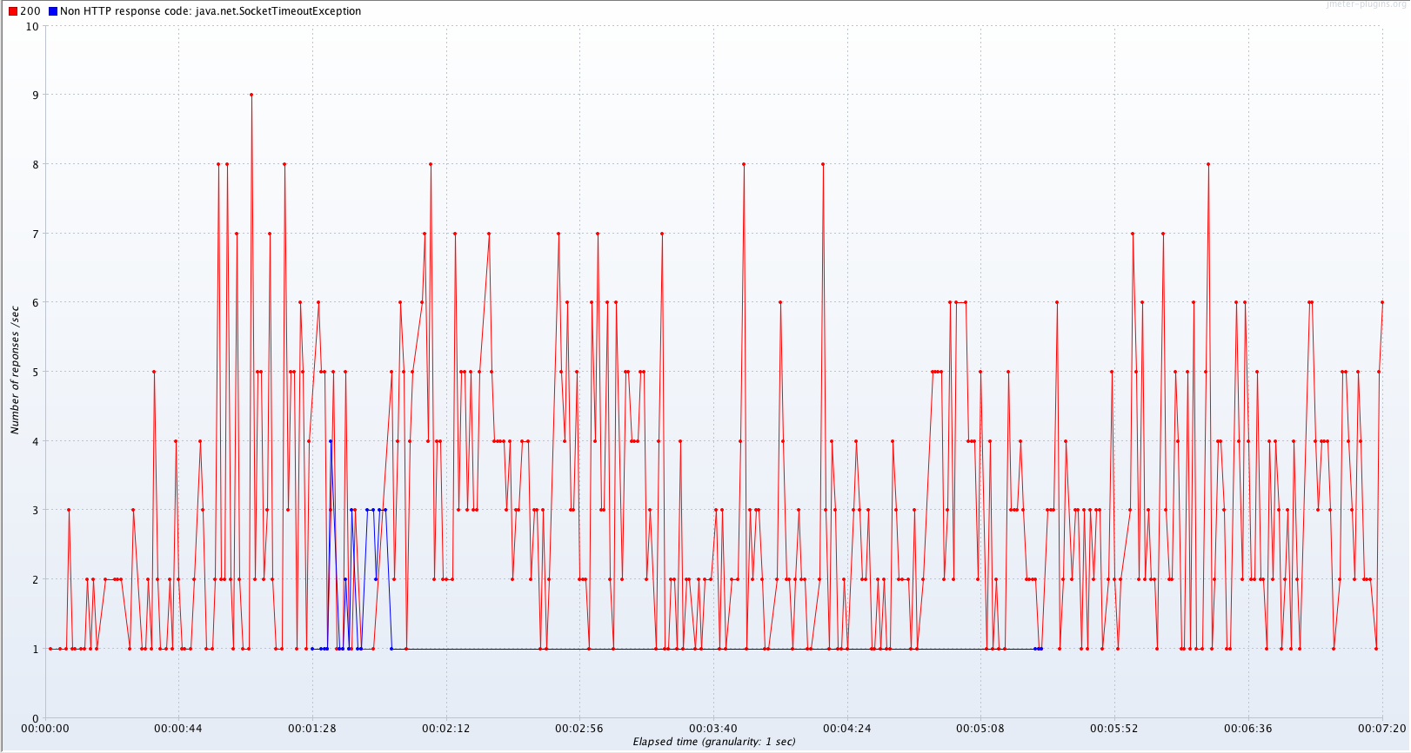
You can also see the error responses for the process bordereau requests around the 5:25 mark. These requests failed due to a request for a db connection from the database pool which timed out after 30s.

Compared this to the response latencies on CHOX v8.6.4 that contain the fix:

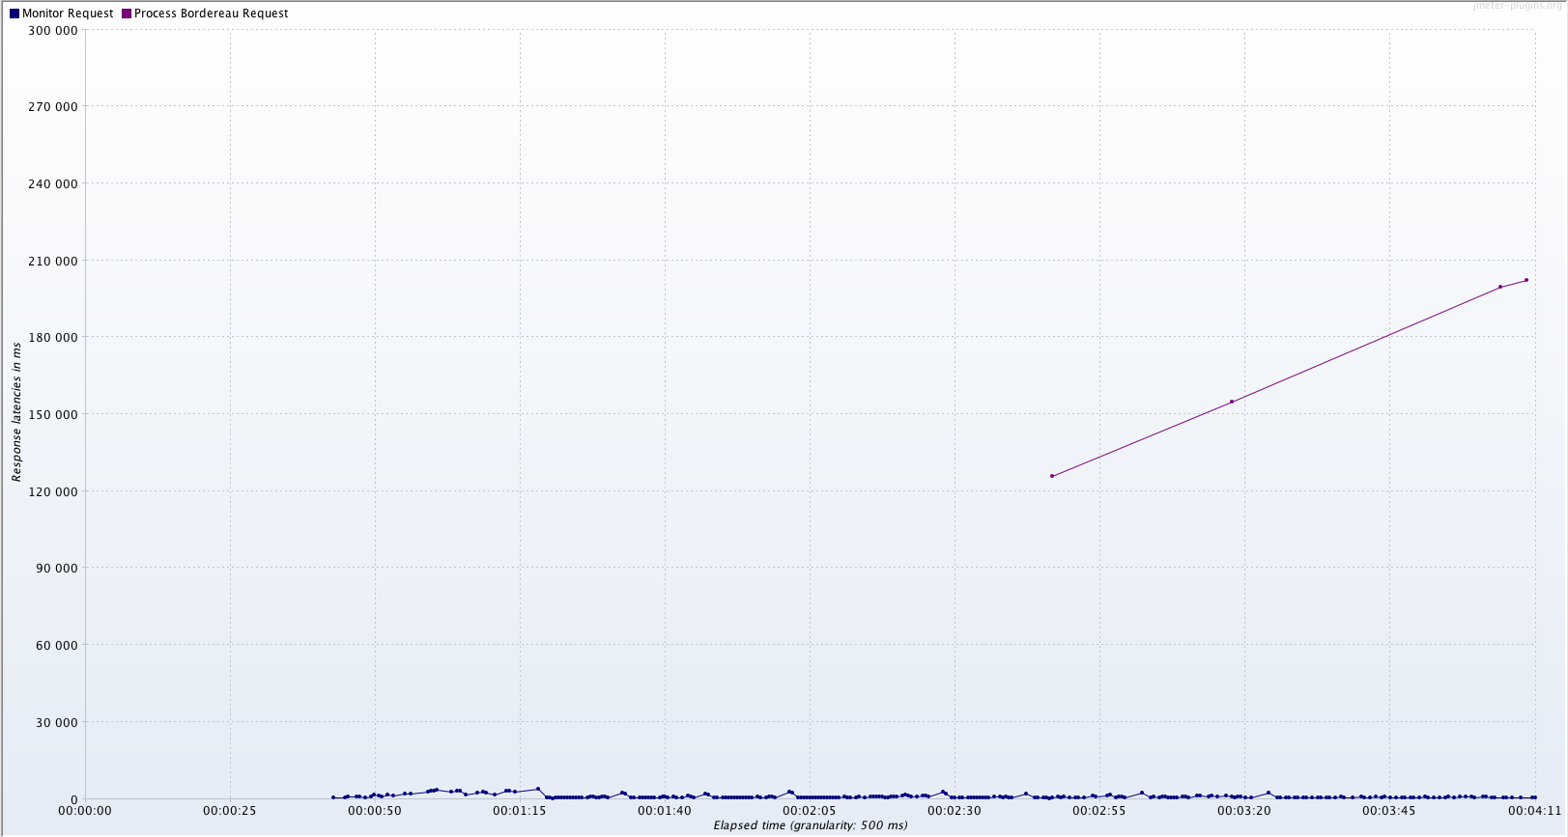

and the latencies for CHOX v8.7.rc1:
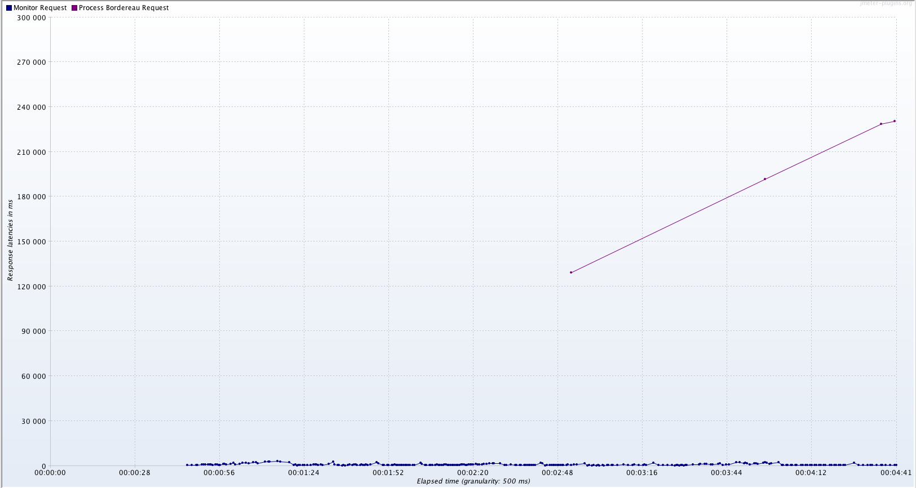

It can be seen that the bordereau process monitoring request response latency is flat over time in both systems were this fix has been applied. These graphs also show a slight increase in the latency to process a bordereau of around 15% between the CHOX v8.6.4 and v8.7.rc1.

The following bar charts also clearly show the difference in response times for the different SUTs:

CHOX v8.5.3
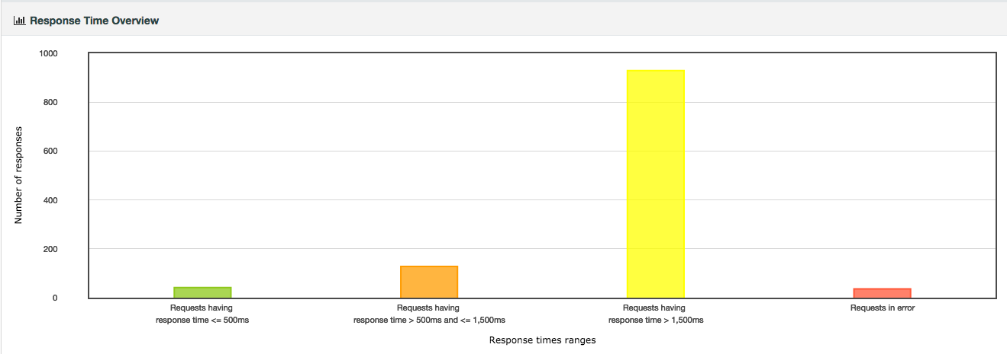

CHOX v8.6.4
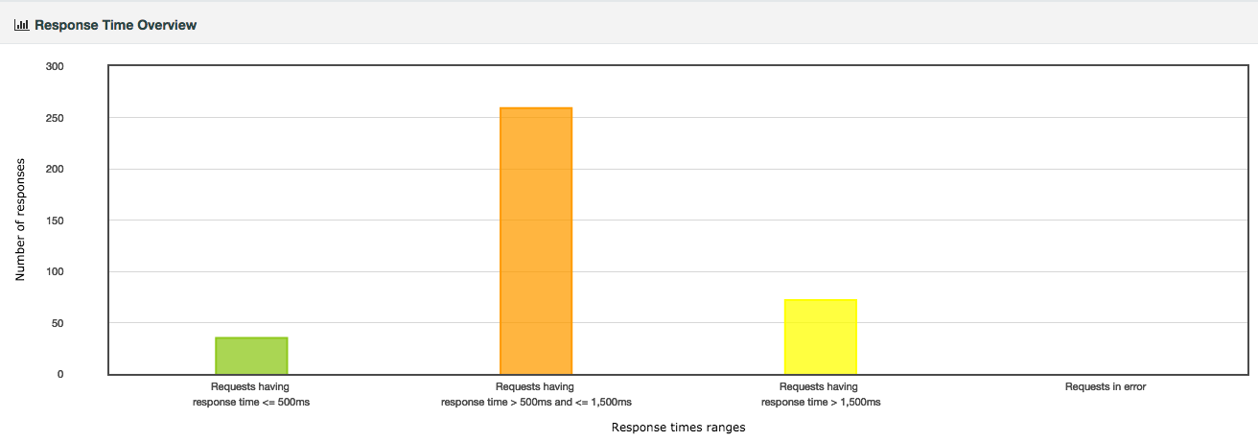
CHOX v8.7.rc1
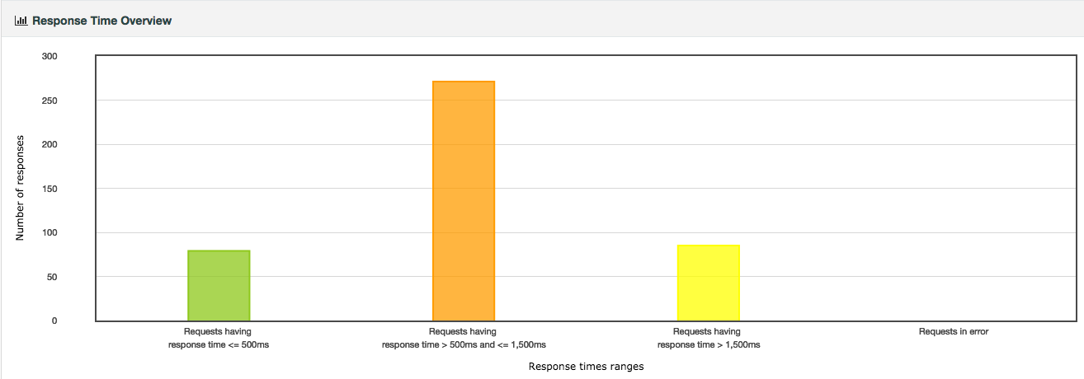

Summary
- The test on CHOX v8.5.3 clearly shows how multiple concurrent bordereau uploads stress the server and cause resource failures for both database connections and tomcat threads.
- The tests on CHOX v8.6.4 and v8.7.rc1 show that the fix has resolved the issue.
- There is a slight (10-15%) increase in the time taken to process a bordereau on CHOX v8.7.rc1 compared to v8.6.4. However, there is a general decrease in latency times for the monitoring requests.

Further Notes and Actions
- The test shall also be run on CHOX v8.7.rc1 under java 8.
- The connection pool handling should be logged during these tests.
- It is difficult to replicate the actual behavior of CHOX for bordereau monitoring as this is handled by javascript timers and not user initiated activity. The methods chosen approximate the pre-fix behavior of a request every 1.5s, and the post-fix behavior of consecutive request. However, this is approximate and it may be better achieved by firing of the requests manually using an executor service in a Beanshell preprocessor (no action to be taken here, just a note for possible alternatives for future development)

Update for JAVA 8
The same tests have now been executed on CHOX v8.7.rc1 under java 8. The tests took 4 minutes and produced no errors:

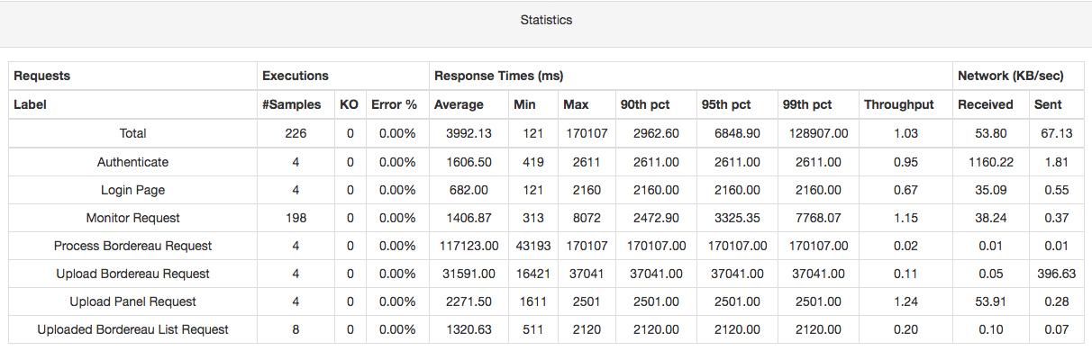

Compared to the java 7 statistics, it can be seen that:
- There were far fewer samples - 226 under java 8 compared to 435 under java 7.
- The time taken to process a bordereau is significantly lower under java 8 compared to java 7. This also explains the fewer number of samples, which are all ‘Monitor’ requests, as these only run when the bordereau is being processed, hence a shorter processing time implies fewer samples to monitor the processing.

Looking at the response latencies over time, you can clearly see the performance improvement in processing a bordereau:
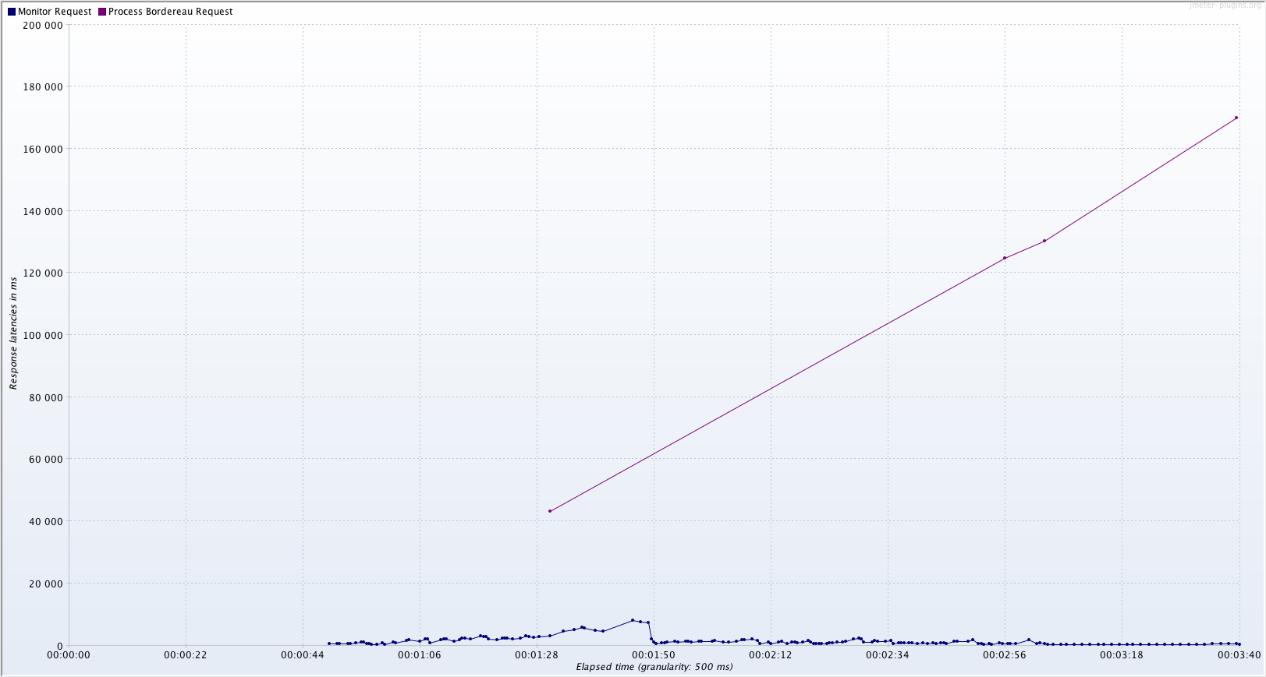

There is an increase in the latency for the Monitor requests between the 00:01:30 – 00:01:50 marks. This can be explained (at least partially) by a young GC pause (STW) of approximately 4s at the 00:01:40 mark. GC analysis also reveals that GC time could be improved by tuning as 35% of GC time was caused by ‘G1 Humongous Allocation’ and 32% by ‘Evacuation Failure’:

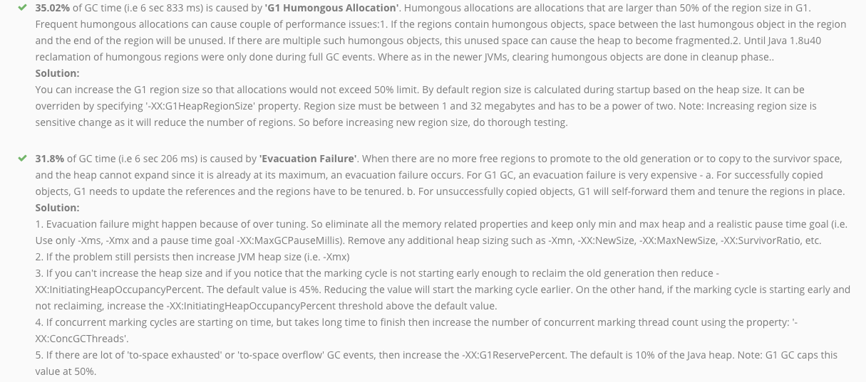

Note, however, that GC activity on test bares no relation to that on the production system.

The response times for other requests looks to be similar to the java 7 response times. Some seem to run slightly faster (Authenticate, Login Page, Upload Panel), and others slightly slower (Upload Bordereau, Upload Bordereau List). Taking into account the total number of samples, the response times overview for java 8 is similar to that of java 7:

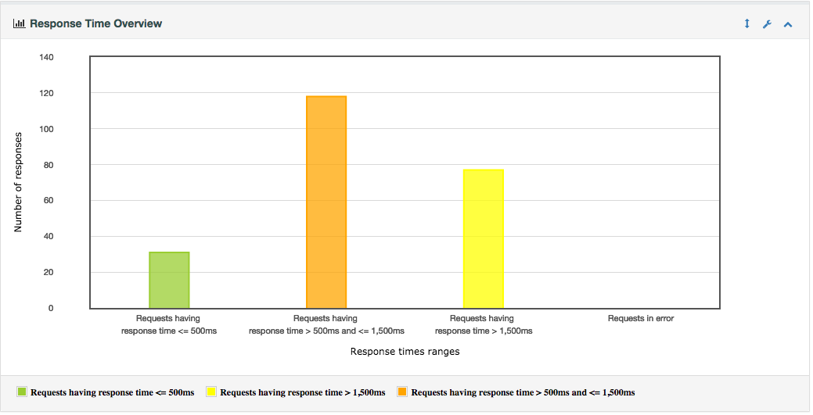

In summary
- No problems exist for multiple concurrent bordereau uploads under Java 8
- The processing of bordereaus is significantly faster under Java 8 compared to Java 7
- For other requests, some seem to be faster while others slightly slower. The full load tests should provide more information in this area.
- GC should be monitored and tuned for Java 8

